CIS 430: Lab Assignment 4

Name: Yuvaraj Vagula

ID: 2862494

Object: Querying a Relational Database COMPANY Database

1. **Updated new changes into Dependent and Works_On tables in DB.**

-- Insert Joe Anderson as a spouse for Joyce English

INSERT INTO DEPENDENT (ESSN, DEPENDENT_NAME, SEX, BDATE, RELATIONSHIP)

VALUES ('453453453', 'Joe Anderson', 'M', NULL, 'Spouse');

-- Insert Erica as a daughter for Jenifer Wallace

INSERT INTO DEPENDENT (ESSN, DEPENDENT_NAME, SEX, BDATE, RELATIONSHIP)

VALUES ('987654321', 'Erica', 'F', GETDATE(), 'Daughter');

-- Insert a new entry in the WORKS_ON table for Jenifer Wallace

INSERT INTO WORKS_ON (ESSN, PNO, HOURS)

VALUES ('987654321', 10, 0);

SELECT * FROM DEPENDENT

SELECT * FROM WORKS_ON

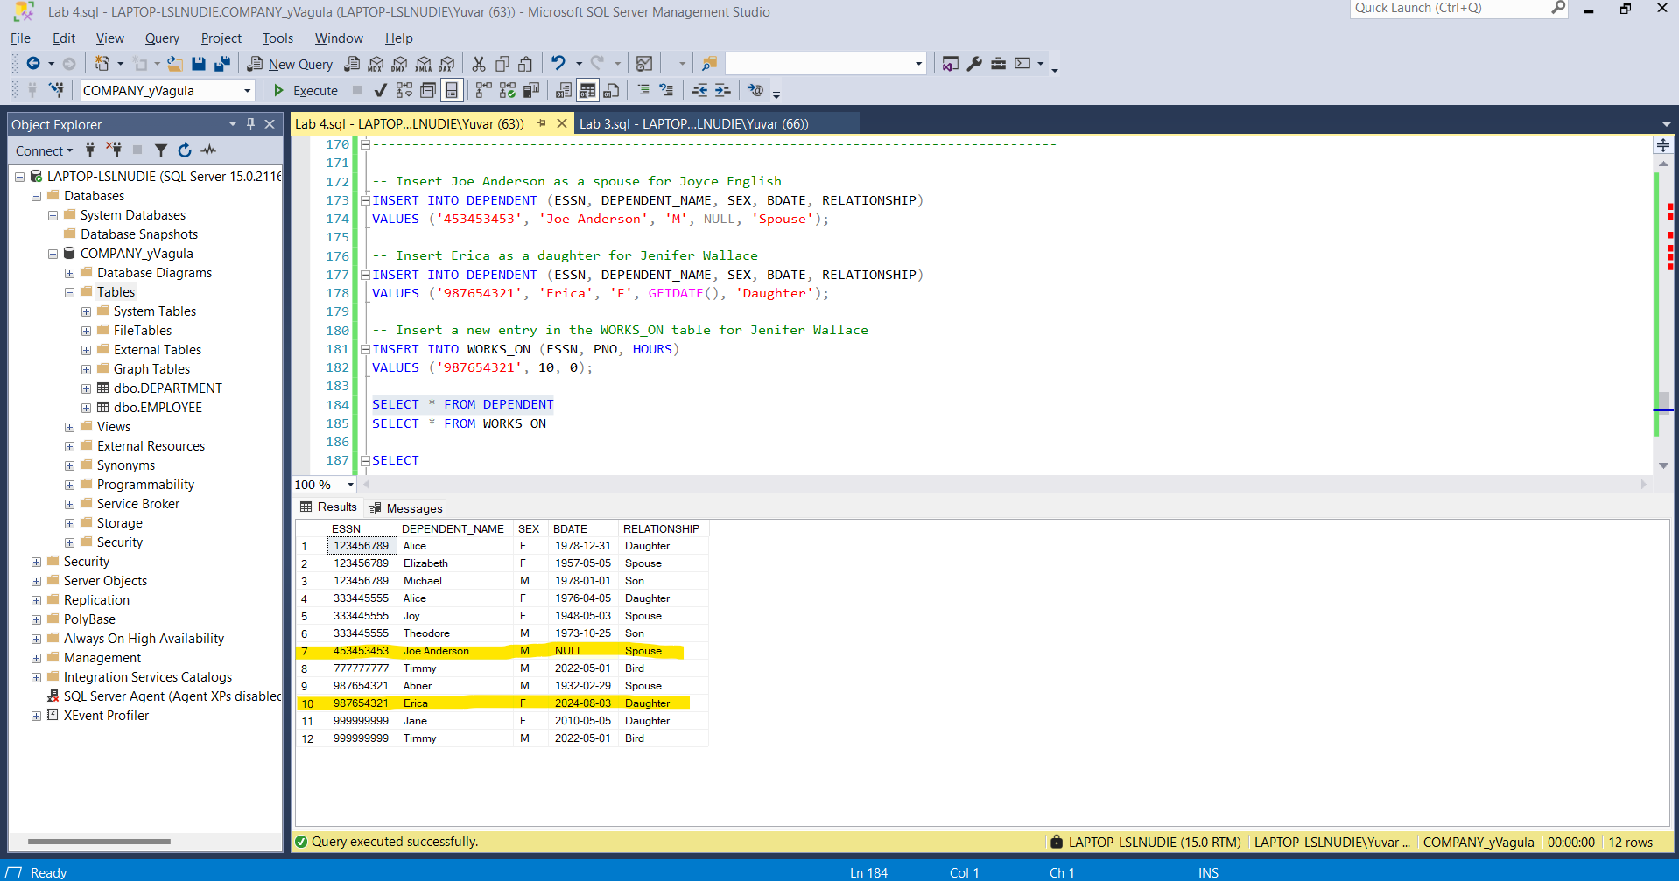

**Q1) For each department, list the first and last name of each employee who is working in the department with the first and last name of his or her immediate supervisor with the department number and name together. Include all the departments including the departments that do not have any employee and all the employees including the ones who do not have any supervisors. List the result in the order of each department number and the first name of each employee.**

SELECT

D.DNUMBER,

D.DNAME,

E.FNAME AS EMP_FNAME,

E.LNAME AS EMP_LNAME,

S.FNAME AS SUP_FNAME,

S.LNAME AS SUP_LNAME

FROM

DEPARTMENT D

LEFT JOIN

EMPLOYEE E ON D.DNUMBER = E.DNO

LEFT JOIN

EMPLOYEE S ON E.SUPERSSN = S.SSN

ORDER BY

D.DNUMBER, E.

**Q1_1) List the same information as Q1 with a change: List all the employees including the ones who do not have any supervisor, but do not include the departments that do not have any employee in the output. So, your result of Q1_1 will list the department 1, 4, 5 and all the related employees with his/her supervisors including the ones who do not have supervisors. So it will be the same as Q1 except the department 7 won’t be included.**

SELECT

D.DNUMBER,

D.DNAME,

E.FNAME AS EMP_FNAME,

E.LNAME AS EMP_LNAME,

S.FNAME AS SUP_FNAME,

S.LNAME AS SUP_LNAME

FROM

DEPARTMENT D

INNER JOIN

EMPLOYEE E ON D.DNUMBER = E.DNO

LEFT JOIN

EMPLOYEE S ON E.SUPERSSN = S.SSN

ORDER BY

D.DNUMBER, E.FNAME;

**Q2) List the name of managers who have no dependents.**

SELECT

E.FNAME,

E.LNAME

FROM

EMPLOYEE E

WHERE

E.SSN IN (SELECT MGRSSN FROM DEPARTMENT)

AND E.SSN NOT IN (SELECT ESSN FROM DEPENDENT);

**Q2_1) Get SSN and the last name of married female employees who work on three or more projects.**

SELECT

E.SSN,

E.LNAME

FROM

EMPLOYEE E

WHERE

E.SEX = 'F'

AND E.SSN IN (SELECT ESSN FROM DEPENDENT WHERE RELATIONSHIP = 'Spouse')

AND (SELECT COUNT(*) FROM WORKS_ON W WHERE W.ESSN = E.SSN) >= 3;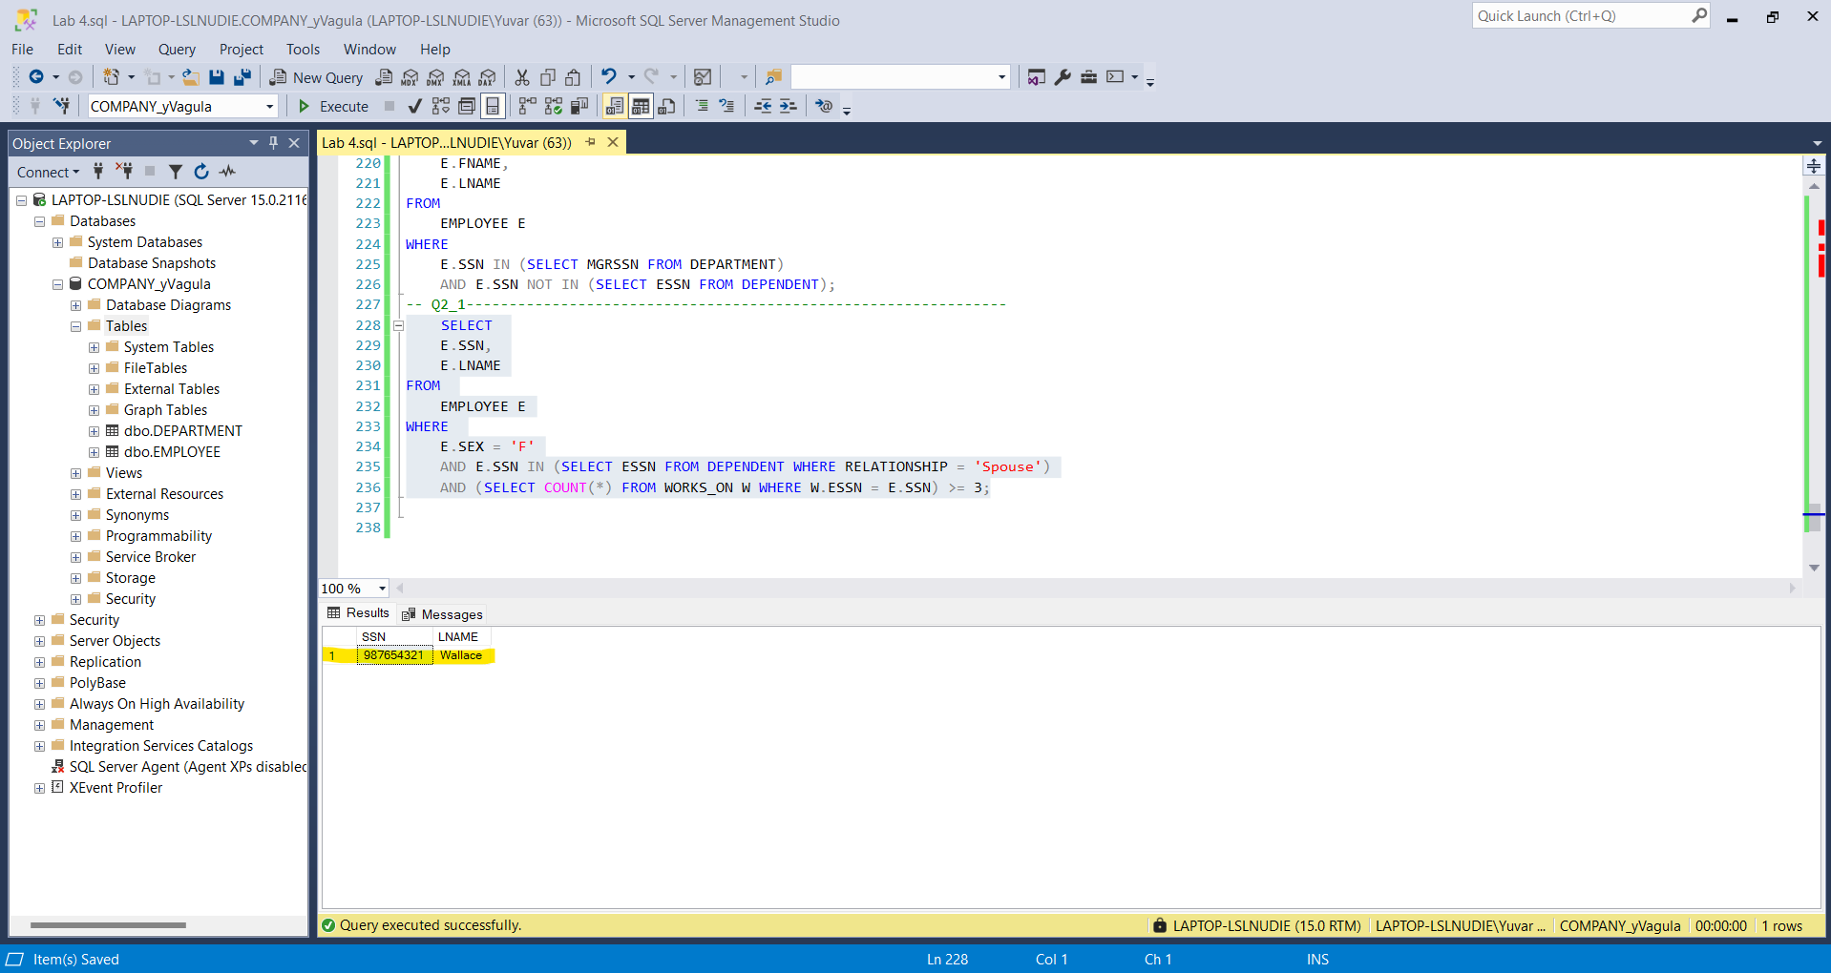

**Q3) List the name of employees who is working for ‘Research’ department and are married but have no children.**

SELECT

E.FNAME,

E.LNAME

FROM

EMPLOYEE E

WHERE

E.DNO = (SELECT DNUMBER FROM DEPARTMENT WHERE DNAME = 'Research')

AND E.SSN IN (SELECT ESSN FROM DEPENDENT WHERE RELATIONSHIP = 'Spouse')

AND E.SSN NOT IN (SELECT ESSN FROM DEPENDENT WHERE RELATIONSHIP IN ('Son', 'Daughter'));

**Q4) Get the last name of married employees who only have daughters.**

SELECT

E.LNAME

FROM

EMPLOYEE E

WHERE

E.SSN IN (SELECT ESSN FROM DEPENDENT WHERE RELATIONSHIP = 'Spouse')

AND E.SSN NOT IN (SELECT ESSN FROM DEPENDENT WHERE RELATIONSHIP = 'Son')

AND E.SSN IN (SELECT ESSN FROM DEPENDENT WHERE RELATIONSHIP = 'Daughter');

**Q5/EXTRA CREDIT) Give the last name and ssn of those employees who work in any project(s) where there are more female than male employees.**

SELECT

DISTINCT E.LNAME,

E.SSN

FROM

EMPLOYEE E

WHERE

E.SSN IN (

SELECT W.ESSN

FROM WORKS_ON W

JOIN PROJECT P ON W.PNO = P.PNUMBER

WHERE (

SELECT COUNT(DISTINCT E2.SSN)

FROM WORKS_ON W2

JOIN EMPLOYEE E2 ON W2.ESSN = E2.SSN

WHERE W2.PNO = P.PNUMBER AND E2.SEX = 'F'

) > (

SELECT COUNT(DISTINCT E2.SSN)

FROM WORKS_ON W2

JOIN EMPLOYEE E2 ON W2.ESSN = E2.SSN

WHERE W2.PNO = P.PNUMBER AND E2.SEX = 'M'

)

);

**PROOF OF PATH AND FILENAME**

